УДК 535.215, 621.472, 535.8, 53.06
TOWARDS THE EXPO-2017 EXHIBITION:
SUSTAINABLE ALTERNATIVES, SOLAR POWER PLANTS AND PHOTOVOLTAIC MARKET INCREASE RENEWABLE ENERGY CAPACITY IN KAZAKHSTAN

I.Kh. Zharekeshev
(Email: SOLARMODUL@mail.ru)

аl-Farabi Kazakh National University, Almaty, Kazakhstan

Kazakhstan is only starting its journey of transition to alternative and renewable energy sources, of which it has a huge abundance. Solar, hydro and wind power; soil, surface water and geothermal energy; biomass, biogas and other organic fuels are used to generate electricity and heat. The new initiatives and measures of the governmental support towards the development of the solar power plants and other renewable energy sources are launched. Photovoltaic is one of the important realms of “green” energy industry, consisting of the renewable energy sources, to which great attention will be paid at the forthcoming world exhibition EXPO-2017. In this paper the economical possibilities and the competitiveness of the photovoltaic converters in the energy market are argued. The potential impact on the domestic industry and environmental protection is discussed. A comparative analysis between the traditional and the alternative energy sources is made for different foreign countries and Kazakhstan.
Key words: renewable energy sources, sustainable economy, solar power plant, PV modules, alternative energies, solar energy conversion, photovoltaics, environment protection, solar cells, ecology

- Introduction
Kazakhstan’s abundance of riches includes the solar radiation. Indeed, the main part of the republic area is wealthy illuminated by the Sun, so that the state receives more than 250 sunny days in a year. Moreover, the south-eastern regions could provide up to 3000 hours of sunshine annually. Therefore, Kazakhstan’s potentials for the electricity production using solar energy are huge enough. This advantage could lead to one of the promising renewable economies all over the world. However, known reserves are still unexploited and new potentials are to be explored.
The photovoltaic industry represents an important technological breakthrough and a rapid-growth technology-transfer in one of the most resources-rich countries. The photovoltaics (PV) is an important component of the sustainable energy economy, which gets green light in the last years [1]. Building solar power plants, developing the photovoltaic market, using rationally the governmental support are increasing the capacity of the renewable energy portion in the republic’s energy industry. Thus, the share of the renewable sources in Kazakhstan’s energy mix should rise from the current 0,5 percent up to 12 percent by the year 2030. The forthcoming strategic goal is to reach an unprecedented level of one half of the whole energy capacity in the country by the year 2050!
The state has launched in 2006 a fund project for long-term loans to promote energy efficiency and investment in renewable sector, so called KAZSEFF – Kazakhstan Sustainable Energy Financing Facility. It is intended for private industrial companies which are willing to make investments in energy saving, effective resources distribution and engaging in renewables with the aim to reduce the total costs. The KAZSEFF project has organized a series of meetings and workshops on industrial modernization and improvement. As a consequence, dozens of innovative projects have been approved for financing across the country. Owing to them, one expects to create an annual saving over 300 GWh, the giant amount of energy which is equivalent to the energy consumption of hundred thousand domestic housings or to 24 million kg of crude oil.
2. Sustainable solutions for energy demand and governmental measures
The Kazakhstan government is funding hydro, wind and solar power plants constructions with the goal to increase alternative energy sources capacity. The development of the domestic market of the photovoltaic convertors and solar collectors gains an additional impulse after releasing a new law about renewable energy sources three years ago. Despite that the usage and of the solar collectors is more extended, in the republic is planned an intensive production of the solar cells and batteries. A new power plant is launched near the capital Astana for producing and refining the silicon of semiconductor purity and the silicon wafers and substrates. In several regions hundreds new solar modules are installed each with the power up to 10 KW. An important goal is to create cheap production of the photovoltaic panels, the prices of which should be lower in comparison with those imported from abroad.
The problems of the alternative energy economy are to be solved together with all its sectors, including hydropower, wind energy, bio-energy, solar thermal and photovoltaics. This is because the abovementioned issues are put forward as priority directions for industry, as stated in the governmental program of the economical development of the Republic of Kazakhstan. The producers of the “green” energy are supported and protected by the law with the guarantee to buy back the generated by them “clean” power capacity according to the state tariffs. These tariffs are firmly fixed for the whole negotiated period of time, during which the power plants are paid off. As a rule the pay-off time ranges between 3 to 5 years, for example, for solar energy panel production. This negotiated price level is estimated from the plant construction costs and supporting working regime costs, but always lower than the average market price level for one KWh. The prices could however be corrected accounting for annual inflation rate. In parallel, the solar energy sector should get an impact from the private investment. At present, the real feasible financial support from the government goes mostly towards the creating sustainable solutions from regenerative water force by building hydro power plants. Other sectors of the “clean-energy” economy are still to be explored in the country.
In February 2013 Deputy Prime Minister of Kazakhstan has announced plans to invest in the construction of hydro, wind and solar power plants to produce additional over 1.0 GW of renewable energy capacity by 2020. These include building 13 wind power plants with the total output of approximately 790 MW, 14 hydropower stations with the capacity of 170 MW and a few solar power plants that are capable to produce about 77 MW. These plans anticipate in building on the economy progress and industrial diversification of the country. This can be accomplished by investing now in solar PV power.
In compliance with various estimates, would the price achieved by the PV method for producing the electricity drop to the level of EUR 0,10 per one KWh, would the photovoltaics become a serious alternative and a firm competitor to other conventional and traditional methods of power generation. Partly this is because PV is absolute environmentally benign, clean and sustainable.
At the end 2012 a new PV module production plant called “Astana Solar” has started to operate in the capital city, Astana. The full production capacity has already been reached: the power level of 60 MW of solar panels annually is expected to increase up to total 100 MW. The heading national company “Kazatomprom” reported that the plant operates fully on the basis of hundred per cent Kazakhstan silicon. Raw materials are extracted in the Sarykol quartz fields containing roughly 1.7 million tons of reserves of quartz with the level of ore impurities at 0.5%.
The building of the solar module’s factory in Astana is a part of a large-scale joint-project realized by the Kazakh-French consortium "KazPV", which involves “Kazatomprom”, “KazSilikon”, “Astana Solar” and “Kazakhstan Solar Silicon” in the partnership with French companies CEA, ECM Technologies and “SEMCO Engineering”. The "Kazsilikon" – a metallurgical complex in the city Ushtobe - currently produces metallurgical silicon at a daily capacity of between 12 to 13 tons with further expansion of the production up to the level of 5000 tons per year. Then a plant in Ust-Kamenogorsk town, located in northeastern part of the republic, is involved in the processing of Ushtobe silicon for further stage of refining. Thus, the launched “KazPV” project is one of the successful endeavors of the governmental program to create PV industry in the country.
Another breakthrough business initiative is the following: a private company BISOL installs a 2 MW solar power plant and a ground-mounted and sun-tracking PV system in Kapshagay area near to Almaty city. The chief-executive officer of the BISOL Group comments: “Investing in solar energy offers great potential and our 2 MW PV system will be amongst the first ones in Kazakhstan”. The assembling of construction is expected to be finished to the end 2013. The system consists of the two parts. The main eastern sector comprises 1400 KW of monocrystalline silicon PV modules firmly mounted on a fixed ground, while the western sector amounts 60 solar tracking setups equipped with 600 KW of the concentrated photovoltaic modules. The two-megawatt solar power plant is the first one of this kind in the republic. Its purpose is to involve the solar radiation as one of the renewable energy sources in meeting the increasing energy needs in the Almaty suburbs, highly inhabited region. It will also have a positive impact on the environmental conditions and will certainly inspire the use of clean technologies.
The government commits itself to increase Kazakhstan use of renewable power sources as a part of balanced, diversified “green” politics to the county’s energy demands. The country has produced sex percent more renewable energy in 2012 than in 2011. This progress, although imperceptible, will have to continue, provided that it meets the state target of a total renewable energy volume of 1040 MW by 2020. Moreover, President N.A. Nazarbaev has pushed forward a policy goal to reach at least 50 percent of all power consumed in the republic by the middle of the century, stemming from alternative and renewable sources.
One of the main issues at the forthcoming world exhibition EXPO, which will be held in the capital of Kazakhstan, Astana in 2017 is renewable energy. Last advances in science and technology have provided us with several alternative means of producing energy on a sustainable level, such as wind, geothermal, biomass, and solar. Of these means, solar, i.e. photovoltaic technologies, delivers the most widely adaptable applications and converts sunlight directly into electrical energy with the highest efficiencies. At the EXPO-2017 exhibition the photovoltaic electrical production will be paid great attention. This is because it is a technically feasible, economically viable, long-term sustainable, environmentally harmless and human-health friendly solution to modern society energy needs.

3. Geographic advantages for use of solar radiation
The use of the sun radiation is not effective in the northern parts of our planet compared to equatorial zone, as shown in Figure 1. However, the application of the solar batteries in the countries of the North Europe (Germany, Holland, France and others) is still profitable. For example, in Germany more than a million householders have PV systems for gaining electricity and warming from the sunlight. In what extent the sun radiation can be useful and effective depends mostly on angle of incident sun rays on the globe surface. At the different geographic longitudes in various seasons and daytime the transmitted amount of heat from the Sun differs.
Despite of widely-spread up-today opinion the usage of solar energy all over the territory of Kazakhstan is doubtless meaningful and profitable, although the angle of incident rays of the Sun onto the surface of the republic in average is substantially less than the right angle. From Shimkent to Petropavlovsk the solar radiation is quite enough to reach 60% of accumulation of energy in order to provide the population with the electricity and warm water. For this purpose the solar collectors should be fixed-mounted under a certain constant angle, i.e. they do not need to lie flatly to the horizon.
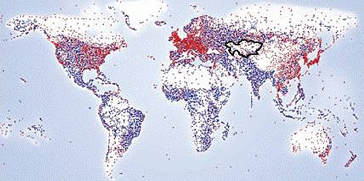

Fig. 1. World distribution of the photovoltaic modules. The intensity of colors corresponds to the number of the installed solar power plants. (From the RETScreen Map NASA Climate Database 2012).

According to the recent monitoring research [2], in southern regions the solar radiation is more intensive compared to the northern regions. Here about 1250-1350 KWh fall down onto square meter of the Earth’s surface annually, while around 800-1000 KWh do in the proximity to the capital Astana. To date, the use of solar energy in Kazakhstan compared to western and southeast countries is insignificant (see Figure 1), despite the preferable geographic location for the higher solar irradiation: the country boasts between 2200 and 3000 sunshine hours annually.
For comparison, the average amount of solar radiation falling down on the Earth equals 1700 KWh per square meter. In spite that this value markedly exceeds the mean level for Kazakhstan, nevertheless the flow of the sunlight is still huge and it delivers colossal amount of energy such that it could be used as an auxiliary and additional source of energy supply for industry and private use. It should be emphasized, that the number of hours of pure sun illumination does not play such an important role as total amount of radiation received by solar collectors does. Taking the cloudiness and other meteorological conditions into account, it is known that solar collectors and photovoltaic panels are able to capture available sun energy and transform it into heat and electricity, respectively.
For example, in Germany, which is positioned to the north compared to Kazakhstan, the entire electric power capacity generated from the sunlight in 2012 has exceeded 9,2 TWh, that comprises 1,7% from the total consumption of the electricity in this country. It should be here noted, that all types of the available renewable energy sources, including wind power (6,1%), bio-energy (4,0%), hydro power plants (3,4%) deliver approximately 16% of the gross volume of the electricity supply in Germany [3]. In 2009 new solar batteries with the power of more than 1500 MW have been installed, that correspond about five atomic power station of the average capacity. Figure 2 shows the Solar-park built in Thüringen Germany in 2009 with the total power of 19 MWp.

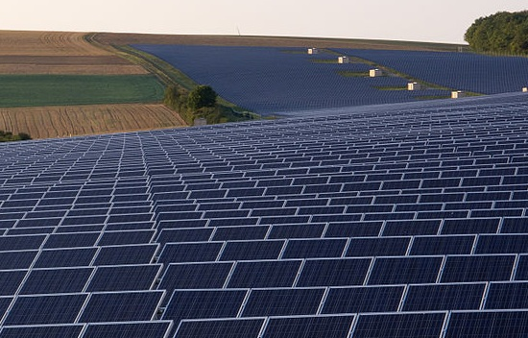

Fig. 2. Giant solar power plant in Germany.

Such a relatively high fraction of the generated electricity, coming from the renewable energy sources, could be explained by various reasons: insufficient national fossils, a continuous decline from the nuclear power stations, dictated by security and environmental protection, absence of oil reservoirs, greenhouse effect, pollution of the nature etc. In addition, measures taking by the German authorities go towards diminishing the portion of CO₂ emission into atmosphere. A similar situation is in France, albeit the market of solar collectors and photovoltaic batteries in this country is somewhat weaker, and the atomic sector is paid more attention.
It is should be noted that not all sun radiation falling on the collector or panel surface is converted into useful energy. A certain amount of energy is lost. A key role for the estimation of the conversion capacity of the solar energy plays the efficiency, a characteristic of a system (e.g. a solar collector or a photovoltaic device), which is defined as a ratio between the useful output energy and the falling input energy [4]. Without going into details of calculations one can estimate roughly, that in order for 800 KWh - 1000 KWh to generate per year in Kazakhstan, one needs 10 square meters of photovoltaic modules’ area. If solar thermal collectors of the same area are exploited instead, then the energy output higher. For instance, one can produce 400-600 KWh from the one square meter of the surface of a solar thermal collector annually.
Location is also of great importance. Solar panels and collectors would be located near the consumer in order to eliminate transportation losses and limiting support structure costs. Particularly, the usage of the autonomic functioning PV sets is much more effective for distant remote public electric grid. This is accomplished by placing solar panels on, or building them into: roofs, house facades, carports, urban infrastructure (see Figure 3 for other PV applications). Any surface that is exposed to sunlight is a potential location for PV. Thus, inconsequential or remote areas could be covered by large number of standard solar modules and supply the electrical power for society. Moreover, they can be easily located in arid regions of Kazakhstan where solar incidence is high and population is low.

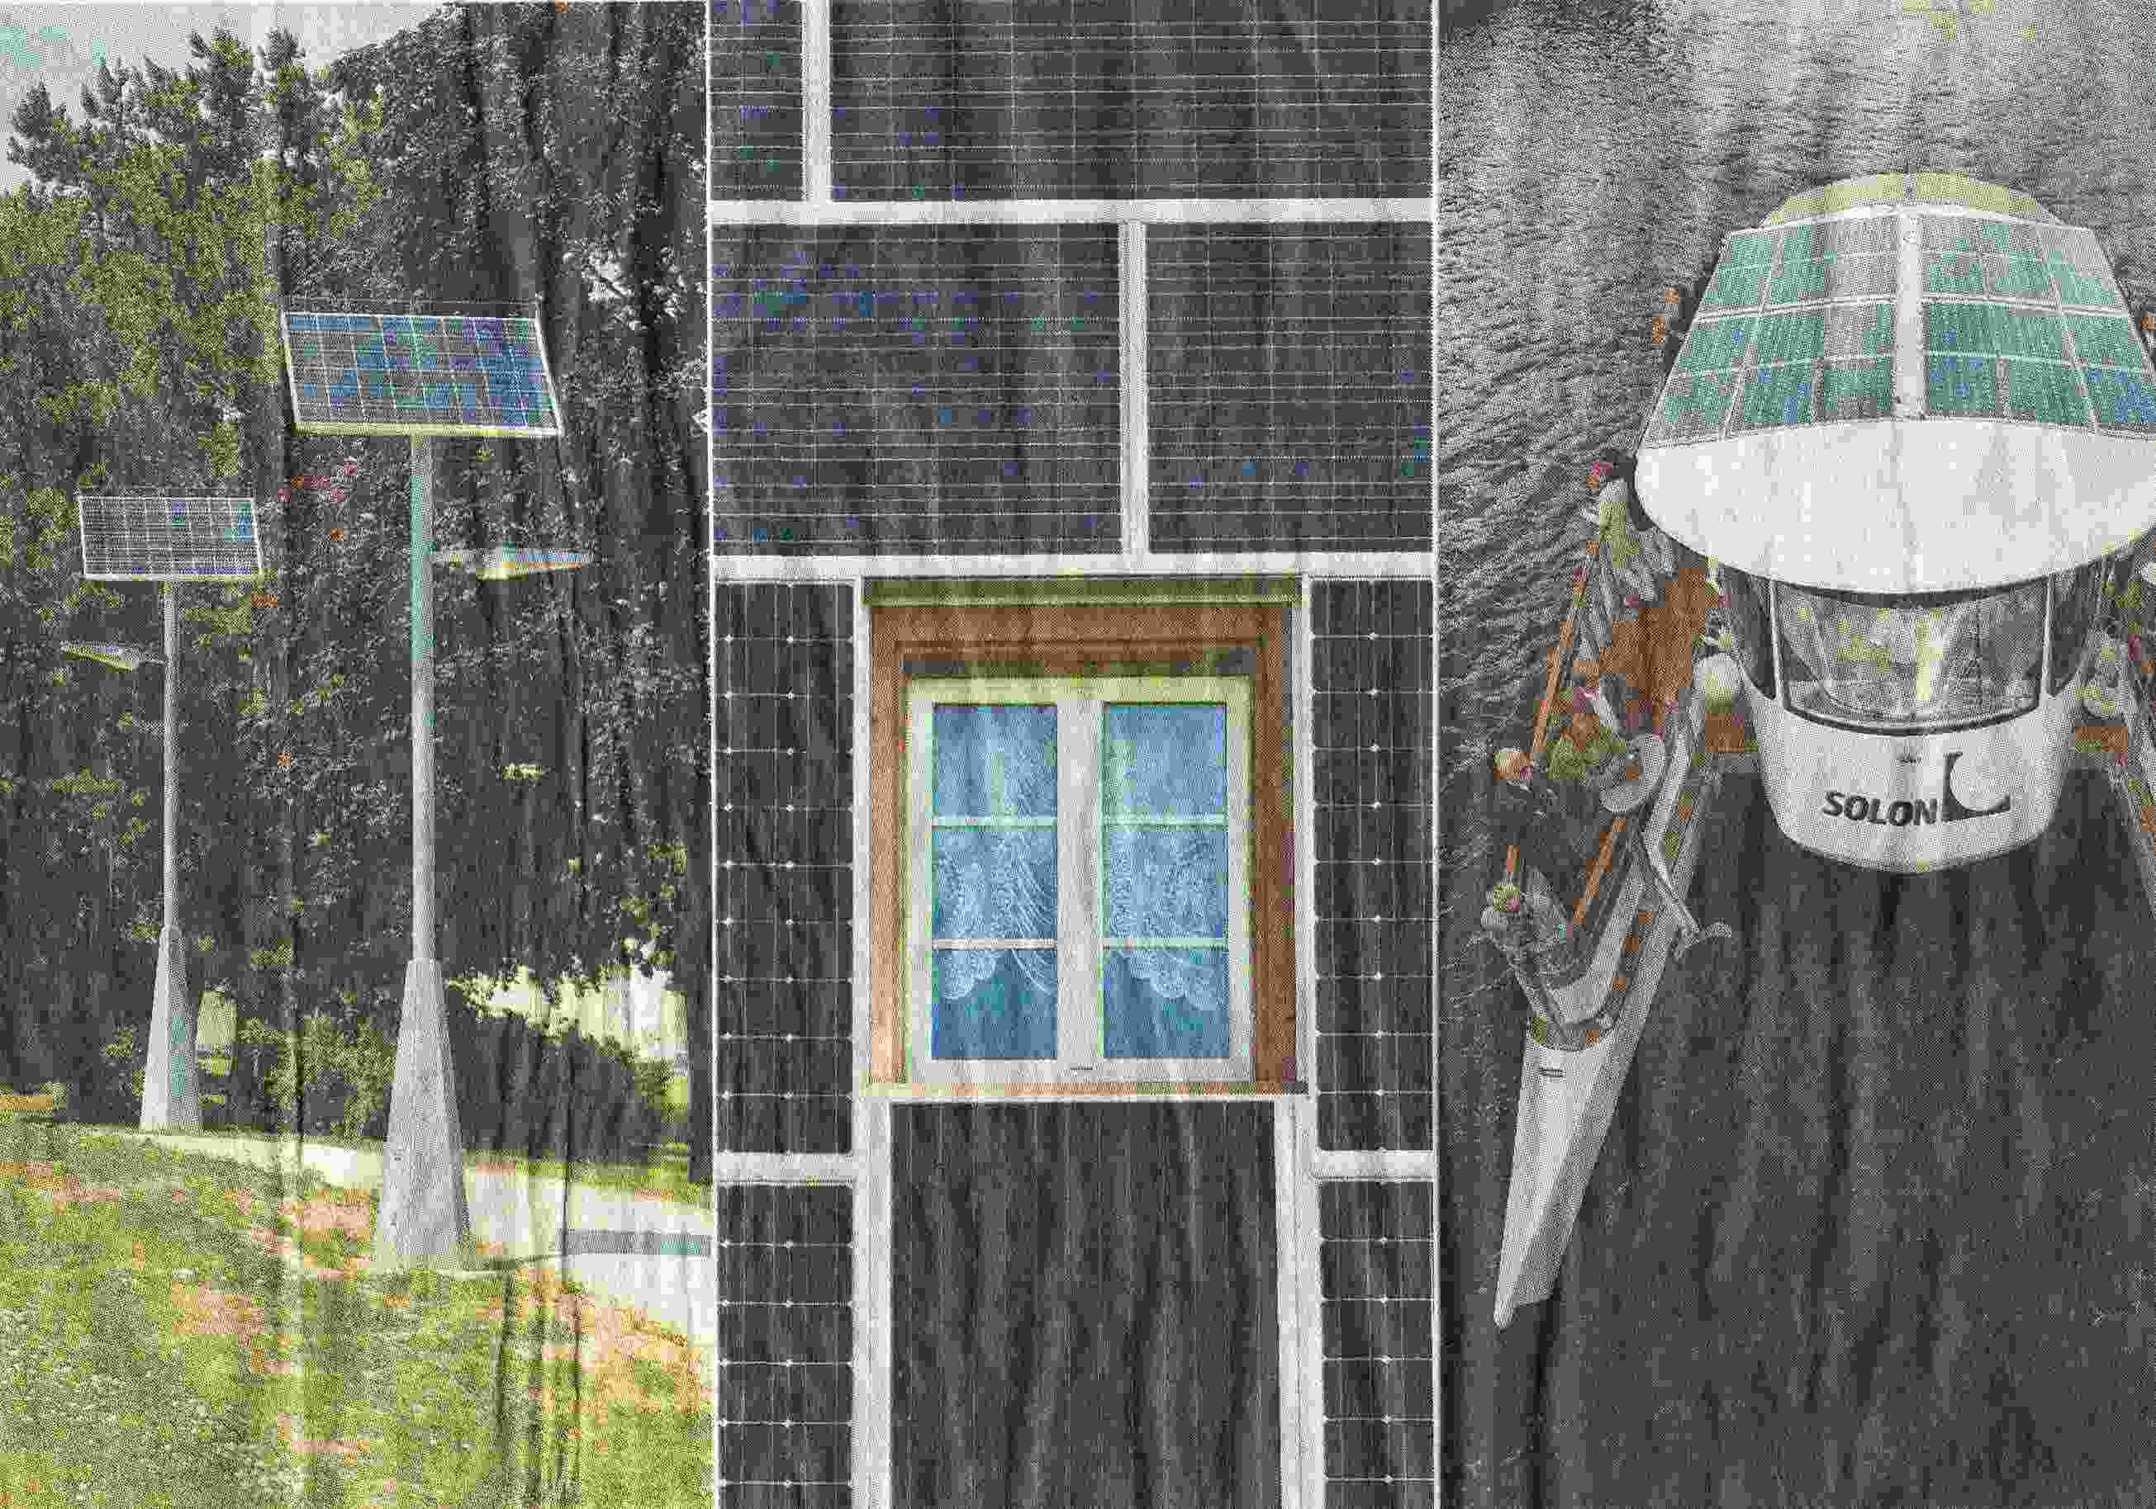

Fig. 3. Examples for solar modules usages are shown for the tonight-illumination, house electricity supply, shipping.

4. World-wide PV market
To the end of 2011 the photovoltaic capacities all over the world reached a record level of 80 GW [5]. Among the largest producers of this “green” energy are China, European Union, Japan and the USA. For example, the alternative energy sources in Germany amounts almost 12% from the total generated energy, that corresponds to the one fifth of the total electrical energy produced. This is over 110 TWh a year. Of this number the photovoltaics occupies 8,2 TWh annually, this comprises about one a half percent of total electric energy produced in 2011. The diagram in the Figure 4 illustrates the distribution of the electric energy over the sources types in Germany (the data are drawn from 2008). To the beginning of 2010 the PV part of energy of the newly-installed solar modules reached 7400 MWp.
Currently the total quantity of the power coming from already installed photoelectric power plants in Germany is more than 22 GW, that garantees the second place in the PV world society after Japan. More than a third of all solar modules is produced in this western country. According to forecasts of diverse statistical agencies on energy, the share of the electrical energy generated from the sun energy can reach the leading level of 15-18% of the total amount produced electricity. However such a tempo can be realized provided that the development of the photovoltaic market grows not less than 8% in a year. In accord with the data of the German organization UVS (Unternehmensvereinigung Solarwirtschaft) [6] the number of companies, occupied in the PV industry has increased from 3000 in 2003 up to 12000 in 2011, while the employment has changed from 13.000 to 83.000 persons for the same period of time.

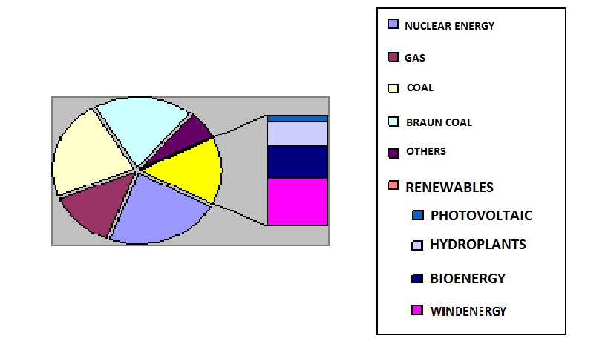

The renewable energy sources amount for 15% from the entire consumption of the electric energy of the total of 617 TWh in a year (gross value) including:
photovoltaics – 0,7% (4 TWh),
hydroplants – 3,4% (21 TWh),
bio - energy – 4,5% (28 TWh)
windenergy – 6,5% (40 TWh)

Fig.4. Distribution of the produced electricity in Germany over the different sources
(from the data according to BDEW/AGEB agency for 2008).

The Japanese PV market has grown with the rate 13% annually in average, starting from 1995. Since then the total volume of production of the solar modules has raised by a factor of ten. Such a rate gave a possibility to this country to generate a financial turnover of $US 2 billion in 2003, and up to $US 12 billion in 2011. The reason of the former leadership of Japan in the world-wide PV market is the constant support from the government [7]. An example of this support is the so-called program “70.000 roofs”, which has been launched in 1997. The German “100.000 roofs” - an analog of the Japanese program - has been initiated at January the first, 1999 [3]. After several years have gone, the next stage of this project named “a million roofs” has been realized. The United States is also trying to create a solar energy option. By far the most ambitious U.S. government program is the Million Solar Roofs Initiative, which will enable businesses and communities to install solar systems on one million rooftops across the United States by 2010 [8].
Upon a new law on renewable energy sources, the energy generated by the “green” producers are bought in feed-in net with the a priori fixed tariffs, which are set by the German government [3,6]. This price level is quite attractive for the producers, because it is firmly fixed for the next 15-20 years starting from the first plug-in to the public net. In 2007 the sold-out price has been settled on the level EUR 0,492 per KWh, in 2010 - EUR 0,467 per KWh, in 2012 – EUR 0,391 per KWh. Since 2013 the tariff decreases further up to EUR 0,274 per KWh. Thus, the final sum of the government support for the national PV market to develop amounts of EUR 12 billion in 2011. Despite that the tariffs go down continuously with years, it is still profitable and attractive for investors and householders to produce the photoelectric energy and sell it. This is because the price for the traditional sources (e.g., fossil fuels, gas) constantly grows. Taking the finite life-time of the solar cell into account (although it can be more than 20-25 years), the producers estimate payback period of the order of 10 years. After that they gain pure profit during the next 10-15 years.
It should be admitted, that over the last several years China is a world-wide top producer of solar photoelectric batteries and modules, which are to be installed. However, concerning the number of the already installed PV capacities which are ready to use, the republic is on the second place after Japan. Nevertheless, the annual development rate of the PV market in this country is much faster compared to its rivals. This could be explained by the high efficiency of the production process, by diminishing the factor price/quality, by the decrease of live resources of PV modules in the account of cheap labor and initial materials. It is doubtless that China in the renewable energy sector, as photovoltaics, becomes a leader in the nearest future. The short survey on the physical backgrounds of photovoltaics – as a important component of renewable energy sources - can be found elsewhere [9,10].

Literature

- Pearce, J. Photovoltaics – A path to sustainable futures // Futures. - 2002. – Vol. 34 (7). - 663–674.
- Energy Information Administration. Country Analysis Brief: Kazakhstan // U.S. Department of Energy. - 2008. - www.eia.doe.gov.
- German PV market // Solarbuzz.com. Retrieved on 3 June 2012; Siemer J. Grössere Anlagen im 100.000-Dächer-Programm // Photon. – 2003. – Vol. 5. – P. 30-35.
- Swanson R. M. Photovoltaics power up // Science. – 2009. - Vol. 324 (5929). – P. 891–892.
- European Photovoltaic Industry Association // Market Report 2011. – 2012. – P.2-43.
- Geiger B. and Witke F. Die energiewirtschaftlichen Daten der Bundesrepublik Deutschland // BWK. – 2003. – B. 1/2. – S. 56-63.
- Mori N. Current status and future prospects of photovoltaic technology development program in Japan // Proceedings of the 28th IEEE Photovoltaic Specialists Conference. – 2000. – P. 1730-1733.
- U.S. Department of Energy.The million solar roofs initiative. // http://www.eren.doe.gov/millionroofs/background.html Retrieved on April 25, 2001.
- Zharekeshev I. Kh. Solar thermal technology and photovoltaics - The components of the alternative energy industry // Bulletin of the National Nuclear Center of the Republic of Kazakhstan. – 2013. – N. 1, Vol. 53. – P. 77-87.
- Zharekeshev I. Kh. Technology of photovoltaic modules: Physical principles of functioning solar cells // Bulletin of the al-Farabi Kazakh National University: Physics series. – 2013. – N. 3, Vol. 46. – P. 37-42.

НА ПУТИ К ВСЕМИРНОЙ ВЫСТАВКЕ EXPO-2017:
ВОЗОБНОВЛЯЕМЫЕ ИСТОЧНИКИ ЭНЕРГИИ, СОЛНЕЧНЫЕ СТАНЦИИ И РЫНОК ФОТОВОЛЬТАИКИ В КАЗАХСТАНЕ

Жарекешев И.Х.
(Email: SolarModul@mail.ru)

Казахский Национальный унивеситет им. аль-Фараби, Алматы, Казахстан

Казахстан начинает интенсивный переход к использованию альтернативных и возобновляемых источников энергии. Имеющиеся в республике огромные ресурсы в виде регенеративной силы воды, солнечной радиации, мощности ветров, геотермальных источников, переработки биомассы и биогаза позволяют производить большое количество электричества и тепла. Фотовольтаика является одним из важных сегментов «зеленой» экономики, относящейся к возобновдяемым источникам энергии. В этой статье рассматриваются экономические возможности и конкурентоспособность фотоэлектрических преобразователей как на отечественном рынке, так и на мировых рынках энергии. Обсуждается потенциальный вклад фотовольтаических солнечных станции в общем энергобаланс страны и их влияние на окружающую среду. В последнии годы разрабатываются инициативы и принимаются меры государственной поддержки в сфере развития возобновляемых источников энергии. В частности, приводится сравнительный анализ с традиционными источниками энергии для ряда зарубежных государств и Казахстана.
Ключевые слова: фотоэлектричество, преобразование солнечной энергии, солнечные элементы, экология, устойчивая экономика, фотопреобразователи, возобновляемые источники, альтернативная энергетика, защита окружающей среды

ЭКСПО-2017 ХАЛЫҚАРАЛЫҚ КӨРМЕ: ЭНЕРГИЯНЫҢ КАЙТА ЖАҢАРТЫЛЫП ОТЫРАТЫН КӨЗДЕРІ, КҮН СӘУЛЕСІ СТАНСАЛАРЫ ЖӘНЕ ҚАЗАҚСТАНДАҒЫ ФОТОВОЛЬТАИКА РЫНОГІ

Жәрекешев И.Х.

әл-Фараби атындағы Қазақ ұлттық университеті, Алматы, Қазақстан

Қазақстан кәзіргі кезде энергия көздерінің дәстүрлі емес және қайта жаңартылып отыратын көздеріне көшуге шынайы бет бұрыс танытып отыр. Республикамыздың судың регенеративтік күші, күн сәулесі радиациясы, желдің күштілігі, геотермалдық көздері, биомасса мен биогаздар сияқты бай ресурстары электрлік пен жылуды көптеп өндіруге мүмкіндік береді. Фотовольтаика – энергияның қайта пайдалануга болатын көзіне тікелей қатысты, ол „жасыл“ экономиканың басты сегменттерінің бірі болып табылады. Мақалада бүкіләлемдік энергия нарығындағы фотоэлектрлік түрлендірғіштердің экономикалық мүмкіндіктері мен бәсекеге қабілеттілігі зерделенген. Соңғы жылдары энергияның қайта пайдалануға болатын көздерін дамыту өрісінде ыждағаттылық танылытуда және оған мемлекеттік қолдау шаралары іске асырылуда. Фотовольтаикалық күн сәулесі стансаларының елдің жалпы энергия балансасындағы әлеутті рөлі және олардың қоршаған ортаға тигізетін әсері талқыланған. Атап айтқанда, бірқатар шет мемлекеттер мен қазақстан үшін энергияның қолданыстағы көздерімен салыстырмалы талдау келтірілген.
Түйін сөздер: фотоэлектрлік, күн энергиясын түрлендіру, күн сәулесі элементтері, экология, фототүрлендіргіштер, қайта жаңартылатын энергия көздері, альтернативтік энергетика.

Сведения об авторе
Жарекешев Иса Хасенович
Доктор физ.-мат. наук, ассоциированный профессор, ведущий научный сотрудник
Научно-исследовательский институт экспериментальной и теоретической физики,
Казахский национальный университет им. Аль-Фараби
п. аль-Фараби 71, 050040, г. Алматы, Казахстан
Контактный тел. +7-777-9707103
Емайл: SolarModul@mail.ru

Author information
Zharekeshev Isa Kh.
Doctor of physical-mathematical sciences, associate professor, leading researcher
Scientific Research Institute of Experimental and Theoretical Physics,
Al-Farabi Kazakh National University
71 Al-Farabi avenue, 050040, Almaty, Kazakhstan
Phone. +7-777-9707103
Email: SolarModul@mail.ru

Автор туралы ақпарат:
Жәрекешев Иса Хасенұлы
физ.-мат.ғыл.докторы, доцент, жетыкші ғылыми қызметкері
ЭжТФ ҒЗИ, Әл-Фараби атындағы Қазақ ұлттық университеті,
әл-Фараби д-ы 71, 050040, Алматы, Қазақстан
тел. 8-777-9707103
Емайл: SolarModul@mail.ru

The power units used throughout the paper are in watts (W) and the energy units in watt-hours (Wh), where K is 10³, MW is 10⁶ watts, GW is 10⁹ watts, and TW is 10¹² watts, respectively. The Wp unit represents a measure of the peak power in watts that a solar cell outputs under 1 sun illumination.

